**Lab Manual Course**

**Programming Fundamentals Lab (CL1002)**

**Semester: BCS Semester**

**Engr. Zakria Bacha**

**Week: 3**

**Operator Precedence & Associativity in C:**

The concept of operator precedence and associativity in C helps in determining which operators will be given priority when there are multiple operators in the expression.

**Example:**

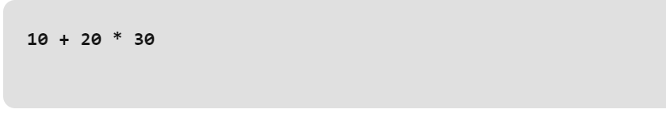

The expression contains two operators, + (plus), and * (multiply). According to the given table, the * has higher precedence than + so, the first evaluation will be

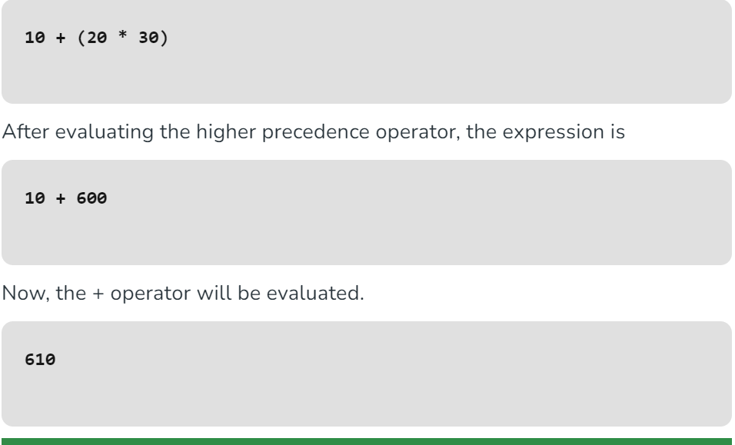

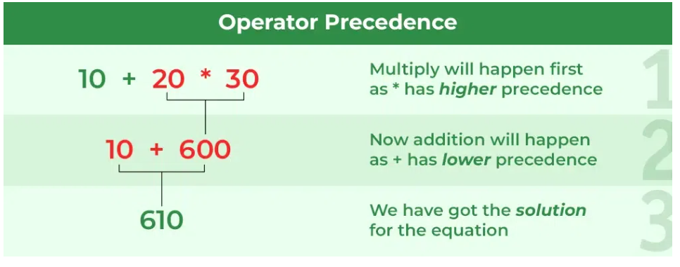

Let’s implement this in C language using Dev IDE.

C

// C Program to implement simple program of operator precedence

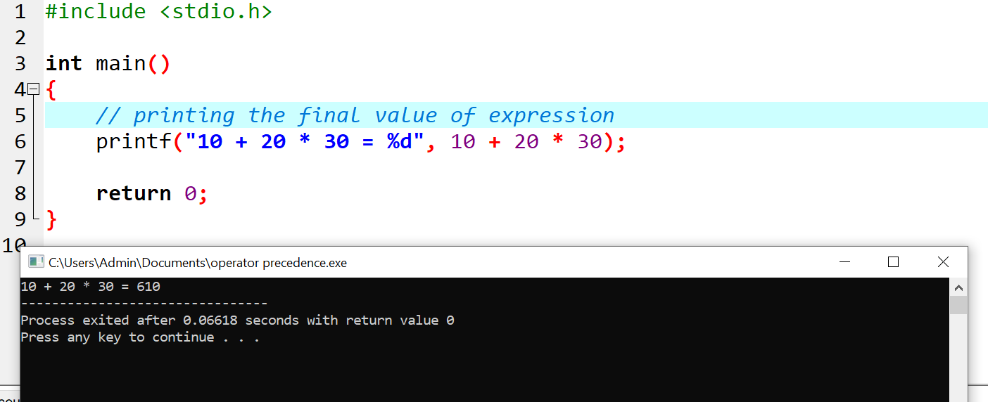

**Operator Associativity**

**Operator associativity** is used when two operators of the same precedence appear in an expression. Associativity can be either from **Left to Right or Right to Left.**

**Int expression = 10*20*30*40*5;**

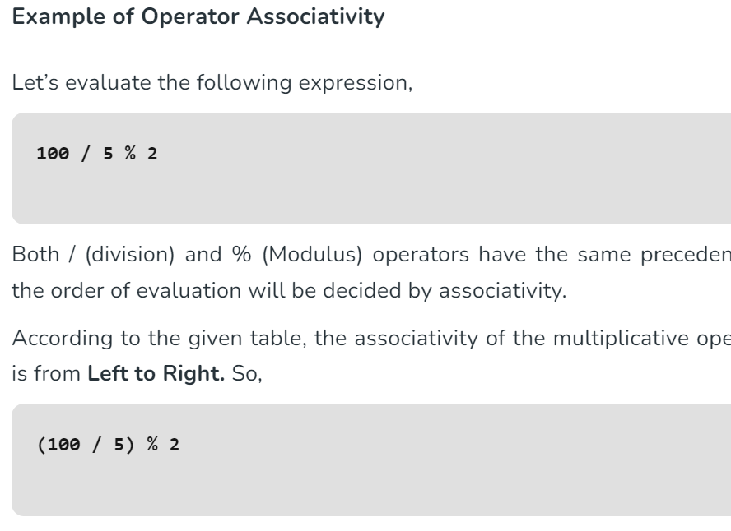

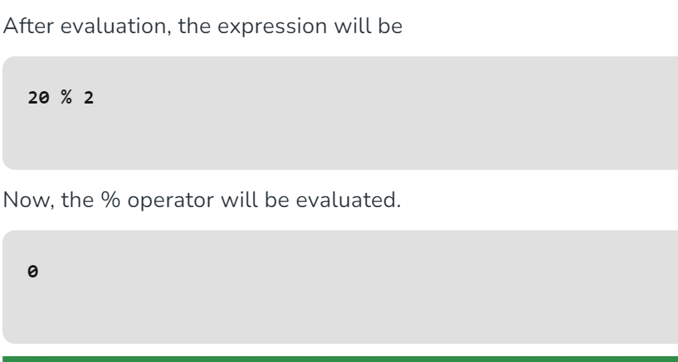

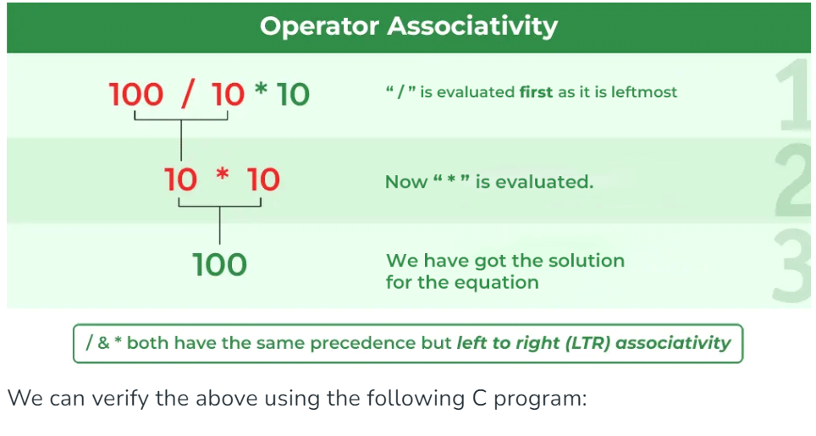

**C code in Dev C++:**

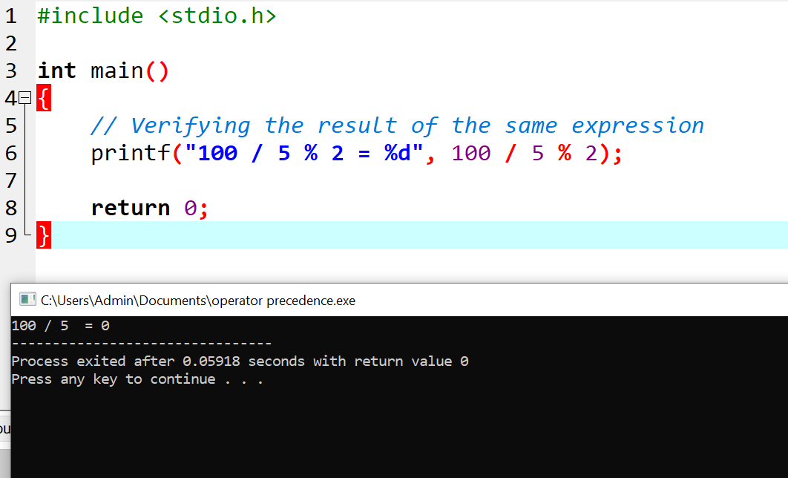

**Table of Operators ( Precedence + Associativity:**

